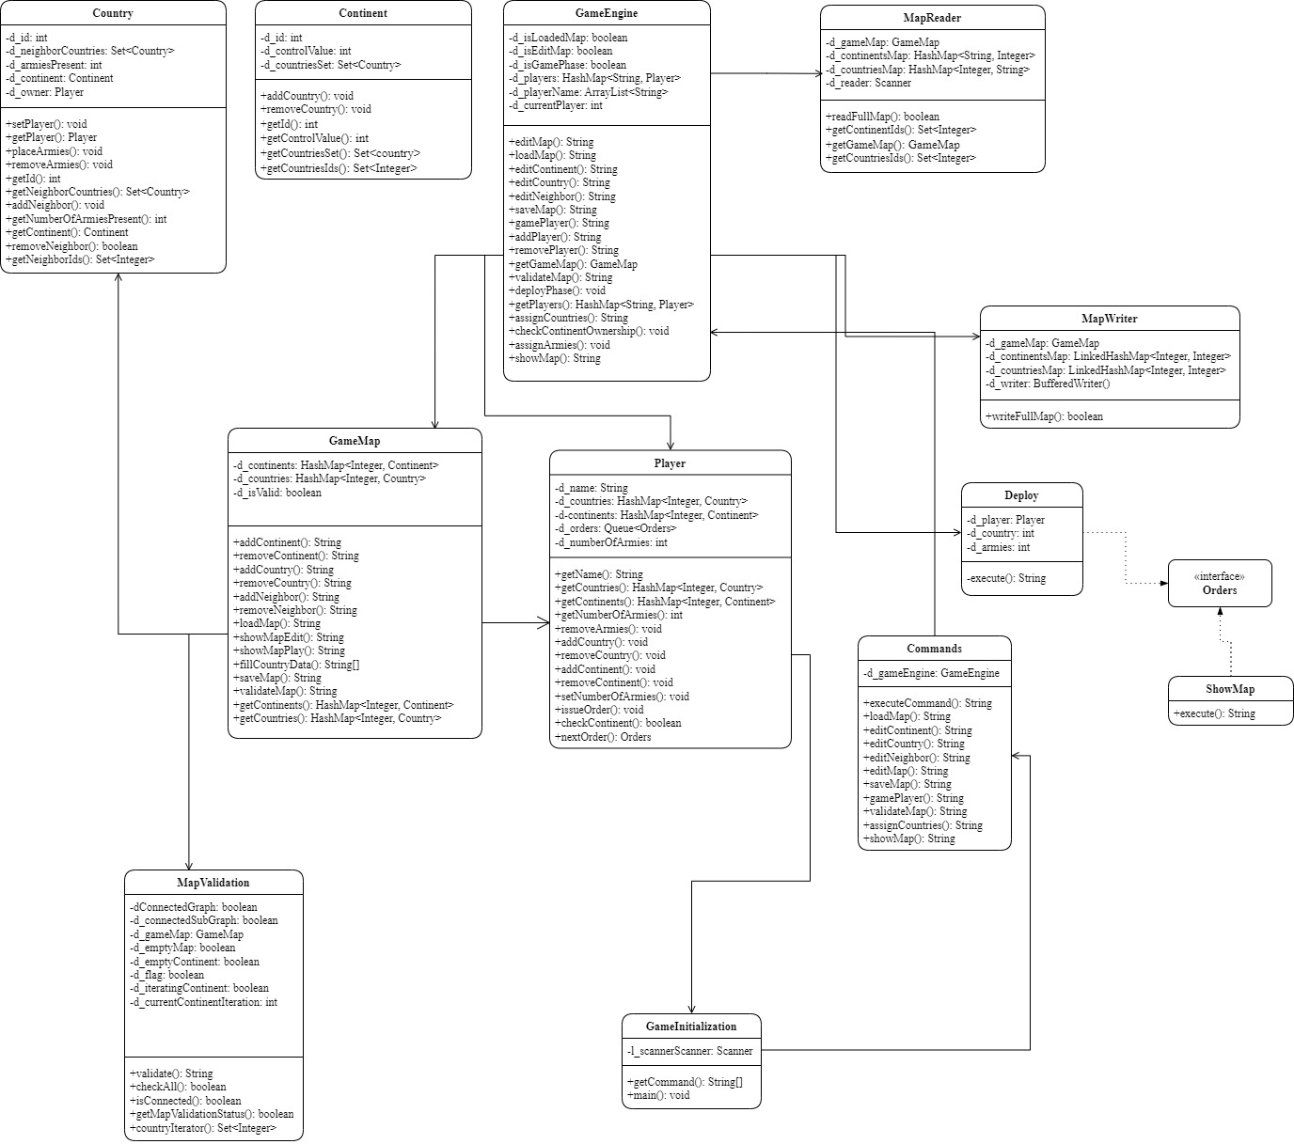

**Description:**

**Class Commands:**

This Class is used to execute all commands by user which are fetched from GameInitialization Class.

**Class GameInitialization:**

This class is used to get user commands and call executeCommand() in Commands Class.

**Class GameEngine:**

This class is used to handle most part of the game. It is controller of the game and all the operations will execute from this class.

**Class Country:**

This class contains all details of country like ID, Continent, Neighbors, Owner, No. of Armies, etc.

**Class Continent:**

This class contains all details of country like ID, Control Value, etc.

**Class Player:**

This class contains all details of player like name of player, ID, dominated Countries and Continents, No. of Armies, Orders etc.

**Class GameMap:**

This class is used to handle all the operations related to map like add/remove Countries and/or Continents, add/remove neighbors, load map, save map, etc.

**Class MapWriter:**

This class is used to write game map as text in map file.

**Class MapReader:**

This class is used to read data from map file.

**Class MapValidation:**

This class is used to validate map which is created by user, according to rules of the game.

**Class Deploy:**

This class is used to deploy armies according to orders issued by the player.

**Class ShowMap:**

This class is used to execute show map command at any time in the game.

**Interface Orders:**

This interface provides structure for execute order.